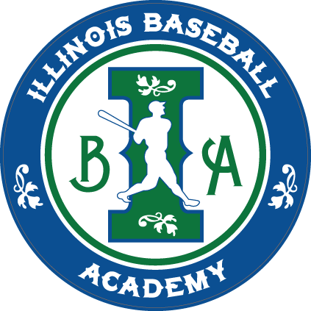
Fill out this form and then have players individually sign up through park district.

League/Age Group (as listed in registration):

Volunteer Coach(es): E-Mail: Phone:
Pre-School / School:
Park District: Glencoe, Kenilworth, Northfield, Wilmette, Winnetka
Players
1.
2.
3.
4.
5.
6.
7.
8.
9.
10.

Questions? E-mail us: HERE

Complete this form and email it back or mail it to:

Illinois Baseball Academy 722 Landwehr Rd Northbrook, IL 60062
www.IllinoisBaseballAcademy.com

